PROJECT TECHNICAL DOCUMENTATION

PROJECT SUMMARY:

A website directed mainly to the Arabian Horse Club, the idea of which is based on registering for the various training courses offered by the club.

PROJECT PROBLEM:

The lack of available information about the training courses and the difficulty of accessing them, which requires either direct communication or communication by phone, may waste time and effort.

PROJECT OBJECTIVES:

Facilitating the registration process for training courses, providing a platform that facilitates access to everything related to the Arabian Horse Club by providing sufficient information about the place and its activities.

PROJECT EXPECTED OUTPUT:

Web application designed to be user-friendly and facilitate the process of reservation for horse training courses.

TECHNOLOGIES USED:

1. HTML/CSS
2. Laravel
3. MySQL

REQUIREMENTS

**Stakeholders: The stakeholders of my app are divided into two types:**

1. User**:** Who can access the website and his functions are as follows:

* The user can reserve a course.
* The user can view course details.
* The user can make a comment on a specific course.
* The user can view other users’ comments.
* The user can search for a specific course.
* The user can view his/her own reservations.
* The user can view his/her profile information.
* The user can edit his/her profile information.

1. Admin: Who manage the courses, users, comments as well as reservations and his functions are as follow:

* Admin can add a new course to the website.
* Admin can edit the information of existing courses.
* Admin can delete an already existing course.
* Admin can add a new user to the website.
* Admin can edit the information of existing users.
* Admin can delete an already existing user.
* Admin can view users’ comments.
* Admin can delete users’ comments.
* Admin can view users’ reservations.

**Non-Functional User Requirements:**

* Availability: our web application is available to users 24 hours a day, there are no restrictions on users regarding time or place.
* Usability: my web application is easy to use.
* Performance: the system is well-programmed so that it doesn’t use a lot of system resources and it is fast.
* Security: in my web application there is a login page for both the user and the admin, I used middlewere in Laravel to restrict who can access the admin pages and make edits addition, and deletion on it as well as I used Cross-site request forgeries (CSRF) to protect my web application from cross-site request forgery (CSRF) attacks.

UML USE CASE DIAGRAM

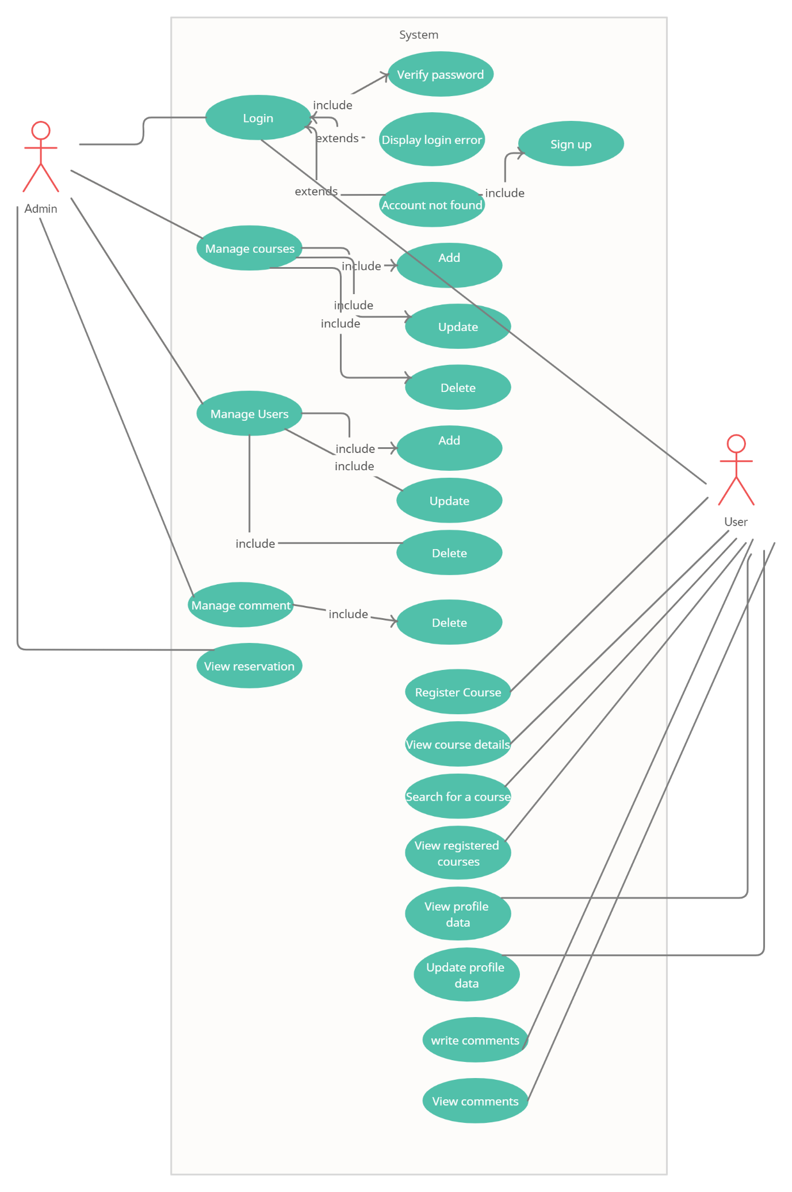

DATABASE SCHEMA

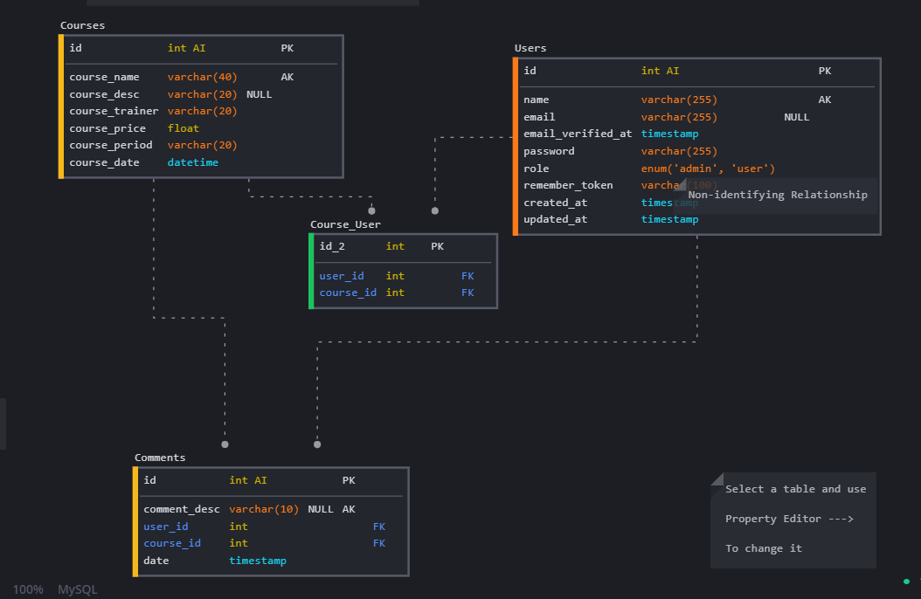

WIRFRAME

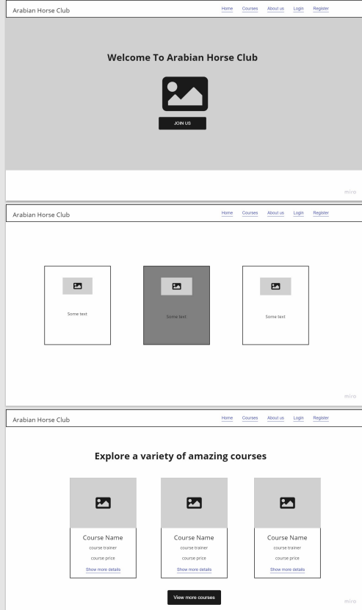

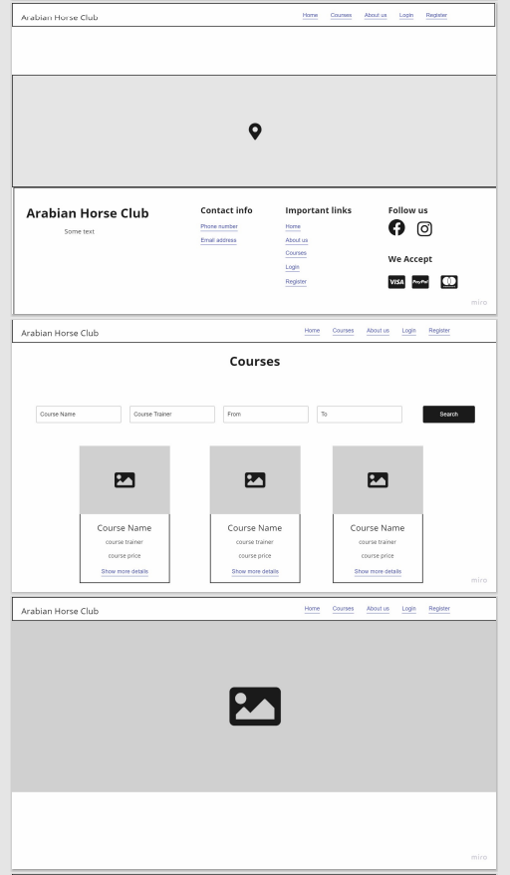

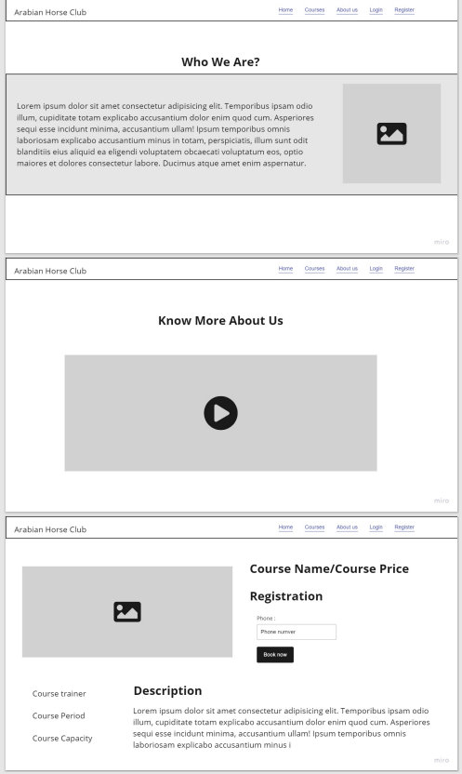

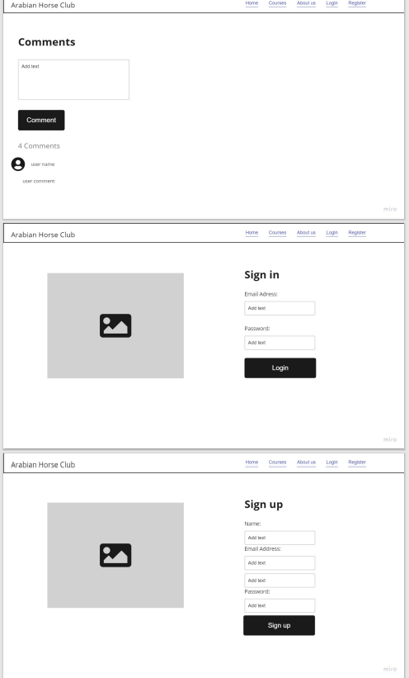

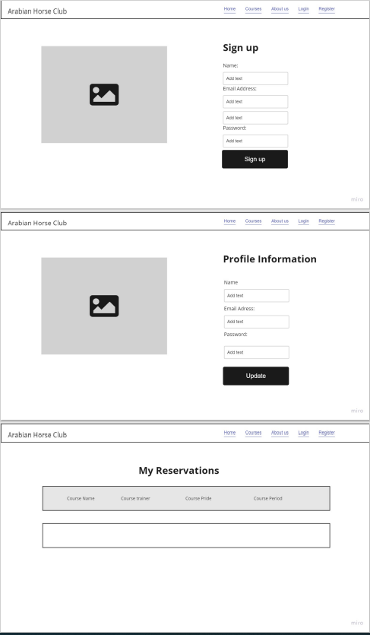

MOCKUP

